The Old Creek (narrative)

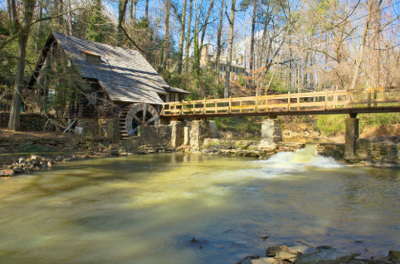

Remember to have (tick each one as you complete it):

Introduction – setting.

Introduction – characters.

Complication or problem.

Resolution (how the problem is solved).

Use great descriptive words in your story.

Punctuate all of your sentences correctly.

Re-read and edit for spelling and to make sure it makes sense.

